**GANPAT UNIVERSITY**

**U. V. PATEL COLLEGE OF ENGINEERING**

**B.Tech CE/IT Semester IV**

**2CEIT404: Python Programming**

**Practical-12: Networking and Multithreading using Python**

1. Create server.py and client.py file and create chat applications for continuous communication between both.

**Server.py**

import socket

LOCALHOST = "127.0.0.1"

PORT = 1234

server = socket.socket(socket.AF_INET,socket.SOCK_STREAM)

server.bind((LOCALHOST,PORT))

server.listen(1)

print('SERVER is ready now: ')

print('Waiting for client : ')

cc, addr= server.accept()

msg = ''

while True:

    in_data = cc.recv(1024)

    msg = in_data.decode()

    if msg=='bye':

        break

    print('From CLient: ',msg)

    out_data = input()

    cc.send(bytes(out_data,'UTF-8'))

print('connection terminated')

**Client.py:**

import socket

LOCALHOST = "127.0.0.1"

PORT = 1234

client = socket.socket(socket.AF_INET,socket.SOCK_STREAM)

client.connect((LOCALHOST,PORT))

client.sendall(bytes("This is client",'UTF-8'))

while True:

    in_data = client.recv(1024)

    print('From server: ',in_data.decode())

    out_data = input()

    client.sendall(bytes(out_data,'UTF-8'))

    if out_data=='bye':

        break

client.close()

**Output:**

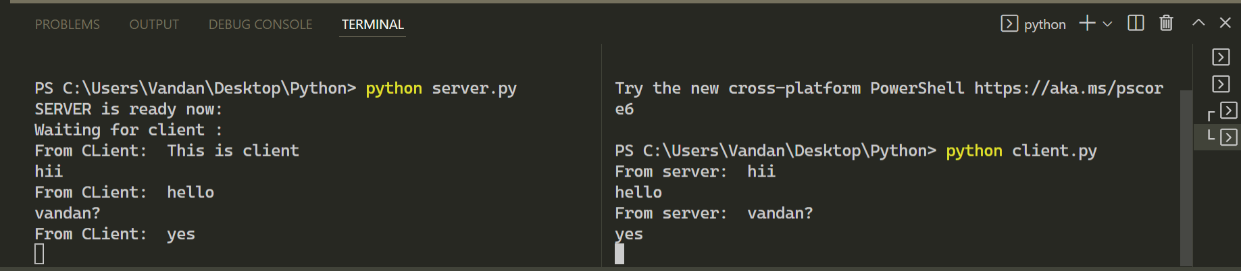

2. Write a python program to demonstrate usage of multi threading.

**Code:**

from threading import *

import time

*class* Myth1(Thread):

*def* run(*self*):

      for i in range(5):

          time.sleep(0.5)

print("First Thread")

*class* Myth2(Thread):

*def* run(*self*):

        for i in range(5):

            time.sleep(0.5)

print("Other thread")

t1 = Myth1()

t2= Myth2()

t1.start()

t2.start()

**Output:**

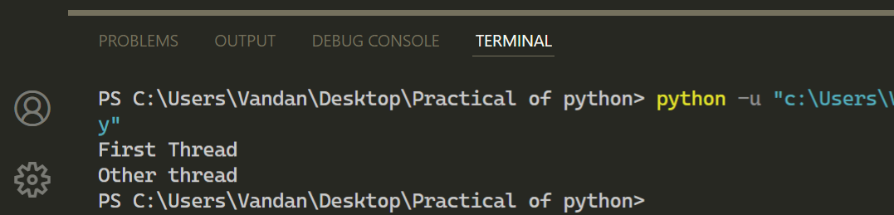

3. Write a python code to send email by attaching .jpeg file as a content.

**Code:**

import smtplib as s

import imghdr

from email.message import EmailMessage

ob = s.SMTP("smtp.gmail.com",587)

ob.starttls()

ob.login("vandankumarpatel20@gnu.ac.in","passwd")

subject = EmailMessage()

subject['Subject'] = "sending image as a content"

subject['From'] = "vandankumarpatel20@gnu.ac.in"

subject['To'] = "vandanpatel5980@gmail.com"

with open('h1.jpg', 'rb') as f:

 image_data = f.read()

 image_type = imghdr.what(f.name)

 image_name = f.name

subject.add_attachment(image_data, *maintype*='image', *subtype*=image_type,

*filename*=image_name)

ob.send_message(subject)

ob.quit()

**Output:**

